Lesson 2 – Marketplace Analysis for E-commerce
Activity 2.1
Identify at least three environments with which business services are provided.

Activity 2.2
For each of the environment influences shown in Figure 2.1, give examples of why it is important to monitor. Relate your answer in a digital business context.

Activity 2.3
Online Ecosystem

Discuss in a group, or make notes to identify, the main companies (E.g. Facebook) and platforms (E.g. tablet devices, mobile devices) used by consumers that are important for companies to review their presence on.

Once you identified the company or service types group them together so that their overall importance can be reviewed.

Activity 2.4
Identify top 3 research tools for assessing a company’s digital marketplace. Among the selected tools which do you think is the most appropriate to use in a company offering “Training Services”? Why?

Activity 2.5
Create a channel chain map for a consumer selecting a school to register for a course and/or training service.

Activity 2.6
List two website examples of the following types of online intermediaries:

- Blog
- Directory
- Access portal
- Marketplace or auction site
- Search Engines

Activity 2.7
What do you think will be the digital business model for a bookstore or bookshop? Create a business model canvas for E-Commerce bookshop. Note: Use the template below

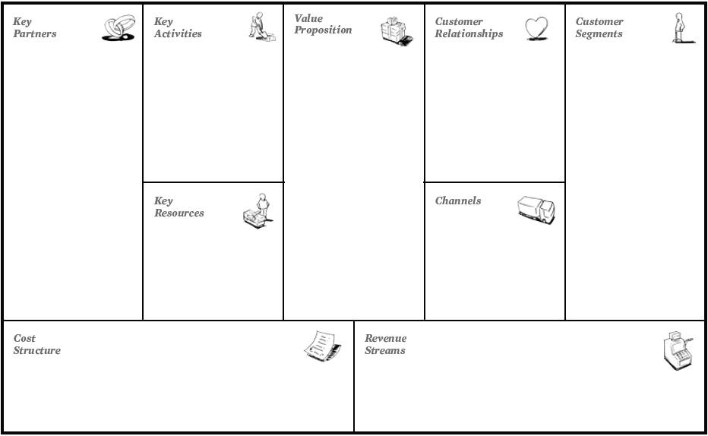

Activity 2.8
Visit the Yahoo! site relevant to your country (from www.yahoo.com) and identify the range of services offered. Which are pure services, and which are basically providing information from other sources?

Activity 2.9
Identify two examples of e-commerce failures.

Self-Assessment Questions to review the topics covered in the lesson

- Explain the concepts of disintermediation and reintermediation with reference to an industry.
- What are the main locations for trading within the electronic marketplace?
- Describe three different revenue models for a portal such as Yahoo or Google.
- Explain business model
- Draw a diagram summarizing the different types of online marketplaces.

